Parth Babbar

Predictive Maintenance for ATMs

Aim:
The Predictive Maintenance for ATMs research seeks to give insights into the performance and maintenance requirements of ATMs across the United States. The report aids data-driven decision-making by assessing critical parameters such as maintenance frequency, downtime length, and incident rates.
Features:
- ATM_ID: Unique identifier for each ATM.
- Location_Type: Type of location (e.g., Standalone, Airport).
- Manufacturer: Manufacturer of the ATM.
- Year_of_Installation: Year the ATM was installed.
- Service_Contract_Type: Type of service contract (e.g., Parts-Only, Full-Service, Self-Service).
- Last_Maintenance_Date: Date of the last maintenance.
- Frequency_of_Maintenance: Number of times maintenance is performed per year.
- Downtime_Duration_hours: Duration of downtime in hours.
- Number_of_Incidents: Number of incidents reported.
- Maintenance_Costs_USD: Maintenance costs in USD.
- Transaction_Volumes: Number of transactions.
- Average_Withdrawal_Amount: Average amount withdrawn per transaction.
- Card_Reader_Error_Rate_percent: Error rate for the card reader.
- Cash_Dispenser_Jam_Rate_percent: Jam rate for the cash dispenser.
- ATM_Age_Years: Age of the ATM in years.
Methodology:
- Data Collection: Collect raw data from a variety of sources, including ATM makers, maintenance logs, and transaction records.
- Data Cleaning:
1.Handle missing values by either assigning suitable values or deleting incomplete data.
2. Standardize data formats (such as date formats and numerical values).
3. Remove duplicate records.
- Using Python, the cleaned and processed data will be turned into a structured dataset ready for analysis. The key phases involve using libraries like pandas for data manipulation, NumPy for numerical calculations, and scikit-learn for preprocessing. Validation processes guarantee that the final dataset is error-free and appropriate for further investigation.
Output:
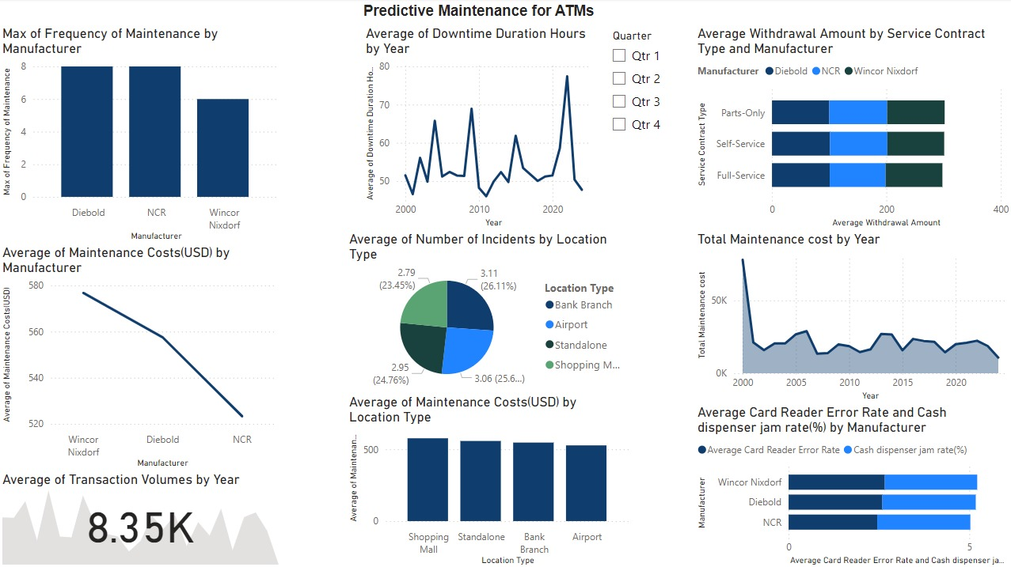
Result Analysis:
- Maximum Frequency of Maintenance by Manufacturer:
1.Diebold and NCR have the greatest maintenance frequency, with around 7 to 8 occurrences each.
2.Wincor Nixdorf has fewer maintenance occurrences, about five.
- Average Downtime Duration Hours by Year:
1.Downtime length has fluctuated throughout the years, with notable peaks in 2007, 2010, and 2020.
2.The longest average downtime length was about 80 hours, while the lowest was little over 50 hours.
- Average Withdrawal Amount Based on Service Contract Type and Manufacturer:
1.Withdrawal amounts are consistent between Diebold and NCR for various service contracts.
2.Wincor Nixdorf indicates somewhat greater withdrawal amounts, particularly for parts-only and self-service contracts.
- Average Maintenance expenses (USD) by Manufacturer:
1. Wincor Nixdorf has the highest maintenance expenses, peaking at $580.
2.Diebold follows, with NCR having the lowest average maintenance expenditures of about $520.
- Average number of incidents per location type:
1.Bank branches have the greatest average number of events (3.11 incidents, 26.11%).
2.The incidence averages for shopping malls and standalone venues are comparable (approximately 3.06 and 2.95 occurrences, respectively).
3.Airports have the lowest average number of occurrences, at 2.79.
- Total maintenance costs by year:
1. Significant initial expenses in 2000, topping $60,000.
2.Maintenance expenses fell from 2000 to 2010, stabilizing at $30K, with minor changes after 2010.
- Average Maintenance Costs (USD) by Location Type: Maintenance expenditures are around $500 across various venue types (shopping malls, standalone, bank branches, and airports).
- Average Transaction Volumes by Year: The average transaction volume fluctuates significantly over time, peaking at around 8.35K.
- Average Card Reader Error Rate and Cash Dispenser Jam Rate (%) by Manufacturer:
1.Wincor Nixdorf has greater mistake and cash dispenser jam rates than Diebold and NCR.
2.Diebold and NCR have comparable mistake and jam rates, with both being relatively low.
Summary:
The dashboard offers insights into ATM predictive maintenance parameters from several manufacturers and locations:
Key insights:
- Manufacturers: Diebold and NCR have more frequent but lower-cost maintenance, whereas Wincor Nixdorf had fewer incidents but higher maintenance costs and mistake rates.
- Downtime and Costs: Significant downtime variations peaked in 2007, 2010, and 2020. Maintenance expenditures have usually dropped since 2000, settling at roughly $30,000.
- Locations: Bank branches have the largest average number of occurrences, whilst airports have the lowest. Maintenance expenditures are constant across all locations, averaging about $500.
- Transaction Volumes: Transaction volumes fluctuate and peak at roughly 8.35K.
- Error Rates: Wincor Nixdorf has a higher error and cash dispenser jam rate.
The dashboard facilitates strategic maintenance planning, cost management, and operational efficiency by giving actionable information regarding manufacturing performance, downtime patterns, and issue frequency.

